Exploratory Data Analysis (EDA)



Hospitality Domain 🏨📊

Project Summary



📝 Project Summary: EDA on Hospitality Domain 🏨📊 Welcome to the EDA Project on Atliq Grands Hospitality Data! 🌟 This project analyses booking trends, cancellationons, and revenue across various hotels under the Atliq brand.



# Hotels under the Atliq brand.

## 🏢 Atliq Seasons | 🏝 Atliq Exotica

🌊 Atliq Bay 🏰 Atliq Palace Each hotel offers a variety of room types:

🛏 Standard | 🛋 Elite | 🏆

## Premium | 👑 Presidential

  Booking Trends & Patterns:



Business



Analyzed seasonal and platform-

Problem:

specific booking behaviors.

  Revenue Insights: Identified cities

and properties facing revenue decline.

  Occupancy Analysis: Evaluated

occupancy rates to uncover

optimization opportunities.

  Cancellations: Examined the

impact of cancellations on overall performance.

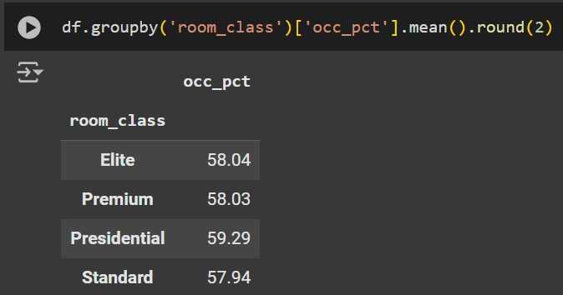

What is an average occupancy rate in each of the room categories?

Print average occupancy rate per city

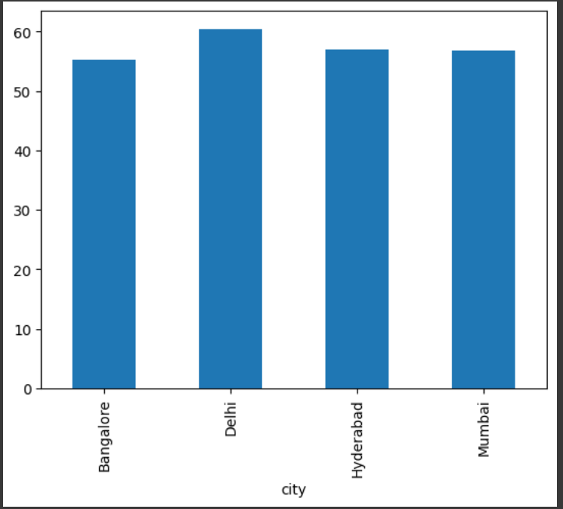

When was the occupancy better?

Weekday or Weekend?

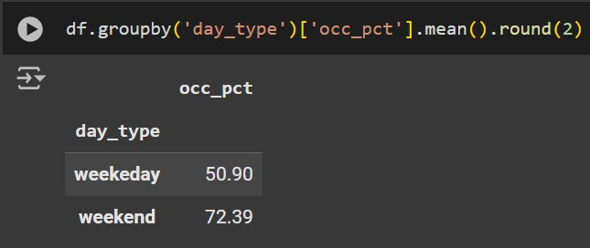

Print month-by-month revenue

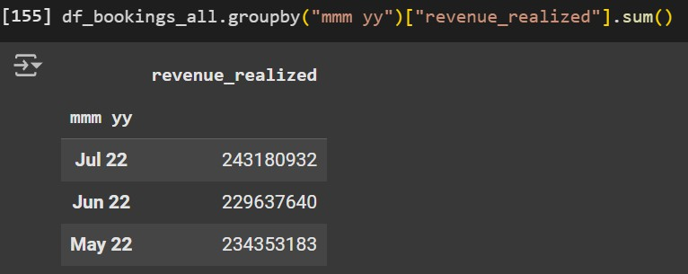

Print a pie chart of revenue realized per booking platform

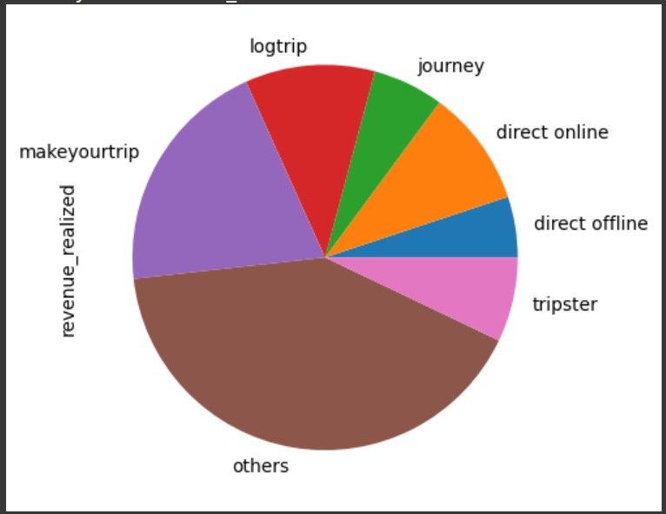

# Conclusions



🏨 Hotel Booking Insights: Key Findings & Conclusion 📊

  Booking Trends & Patterns 📅:

Occupancy rates peaked on weekends (72.3%) compared to weekdays (50.9%). Seasonal trends showed higher revenue in July, followed by May and June.

  Revenue Insights 💰:

The top-performing cities in terms of occupancy are Delhi (60%), Hyderabad (58%), Mumbai (58%), and Bangalore (55%).

Revenue was highest from MakeYourTrip, followed by LogTrip and Journey Platform.

  Occupancy Analysis 🛏:

Average occupancy rates across room categories were consistent: Elite: 58%

Premium: 58%

Presidential: 59.3%

Standard: 57.9%

  Cancellations 🚫:

Cancellations significantly impacted revenue performance, highlighting a need for better cancellation policies or incentives for confirmed bookings.

# Recommendations



✨

Focus on weekend promotions to maximize occupancy.

Enhance partnerships with top-performing platforms (MakeYourTrip, LogTrip) for better visibility.

Address revenue drops in cities with lower occupancy rates (Bangalore).

Optimize inventory management during peak months (July, May, June).

📈 Data-driven strategies can lead to improved occupancy, higher revenue, and better overall performance! 🚀